## **Q:\StaffShared1\CateringNew\Rhys CFD\Corporate identity\Campus Food and Drink\Campus Food and Drink\QUB_CampusFoodDrink_Red_LS.png**

**CAMPUS FOOD, DRINK AND RETAIL FOOD ALLERGY POLICY**

Table of Contents

[1](#_Toc176070747)

[**1.0 INTRODUCTION** 2](#_Toc176070748)

[**2.0 OBJECTIVES OF THIS POLICY** 2](#_Toc176070749)

[**3.0 WHAT IS A FOOD ALLERGY?** 2](#_Toc176070750)

[**4.0 WHAT IS A FOOD INTOLERANCE?** 2](#_Toc176070751)

[**5.0 WHO IS AT RISK?** 2](#_Toc176070752)

[**6.0 OUR COMMITMENT** 3](#_Toc176070753)

[**7.0 THE 14 KEY ALLERGENS** 3](#_Toc176070754)

[**8.0 KEY CONTACT** 4](#_Toc176070755)

## **1.0 INTRODUCTION**

Campus Food, Drink and Retail is committed to reducing the risk to students, staff and visitors with regard to the provision of food and the consumption of allergens in food, which could lead to an allergic reaction. Whilst Campus Food, Drink and Retail is unable to guarantee an allergen free environment our aim is to minimise the risk through the implementation of compliance set by Council, staff training and customer awareness to enable self-responsibility. As a result, below is our Food Allergy Policy, inclusive of a response to possible emergencies.

## **2.0 OBJECTIVES OF THIS POLICY**

To highlight the 14 key allergens to all customers and staff.

To promote food allergy awareness to staff, students and visitors to Campus Food, Drink and Retail.

To highlight the food allergy and food hygiene training Campus Food, Drink and Retail staff are provided with.

To ensure appropriate information and support is available for catering staff and customers.

## **3.0 WHAT IS A FOOD ALLERGY?**

Food allergies affect the body’s immune system. The body reacts to certain allergens in food by producing antibodies which can cause immediate and sometimes severe symptoms, such as: itching or strange metallic taste in the mouth, swelling of the throat and tongue; difficulty in swallowing or speaking; abdominal cramps, nausea and vomiting; skin hives (nettle rash) anywhere on the body. In most extreme cases, difficulties in breathing and a severe fall in blood pressure (anaphylactic shock) can prove fatal.

## **4.0 WHAT IS A FOOD INTOLERANCE?**

This does not involve the immune system in the same way and is not usually as severe as a food allergy. Symptoms usually take longer to appear and may include headaches, fatigue and digestive problems. Food intolerance is harder to diagnose than a food allergy. The person with a known allergen trigger may know what food ingredient will provoke a reaction. However, they may well have eaten this food or a specific dish previously and had no adverse reaction. Coeliac Disease, coeliac disease is a lifelong autoimmune disease caused by a reaction to gluten. 1 in 100 people have the condition. Symptoms include bloating, diarrhoea, nausea, wind, constipation, tiredness, sudden or unexpected weight loss, hair loss and anaemia. Once diagnosed, it is treated by following a gluten free diet for life.

## **5.0 WHO IS AT RISK?**

Anybody can develop a food allergy or intolerance at any time in their life, irrespective of whether they have consumed the food previously. A person with an allergy is at risk even if they consume a small amount of the food allergen. Food allergies and intolerances are life changing. In the UK they affect around 8% of children and 2% of adults. In December 2014, the law on how allergen information is provided by food businesses changed to make it easier when buying food or eating out with an allergy or intolerance.

Students and young people living away from home are a vulnerable group who may be at higher risk if they have allergies. This is due to several factors that are associated with learning to look after themselves in a new environment and, in addition, possibly not wanting to appear different from their peer group. It is because of this high-risk group that the Catering Department will provide as much information as possible to any customers with food allergies or intolerance.

## **6.0 OUR COMMITMENT**

Within the Campus Food, Drink and Retail directorate, we are committed to ensuring that all staff have the necessary resources to allow them to carry out their roles safely and effectively. In relation to Food allergies, this means that we are committed to facilitating Food Safety and Food Allergen training for all full-time food handlers within the team. All casual service staff engaged in the department must also be trained on food allergy awareness by completing an online allergy awareness course as part of their induction process. All training records will be maintained by the management team and stored in staff personnel files which will be regularly updated. Furthermore, as well as onsite first aiders through our security team, we have a minimum of one team member in each of our site who have completed their First Aid training and are prepared to respond to possible emergencies.

## **7.0 THE 14 KEY ALLERGENS**

Under current legislation, there are 14 major allergens, shown below, which must be clearly labelled if they are present in the food on offer. (Although customers may report allergies to other foods that are not listed below.)

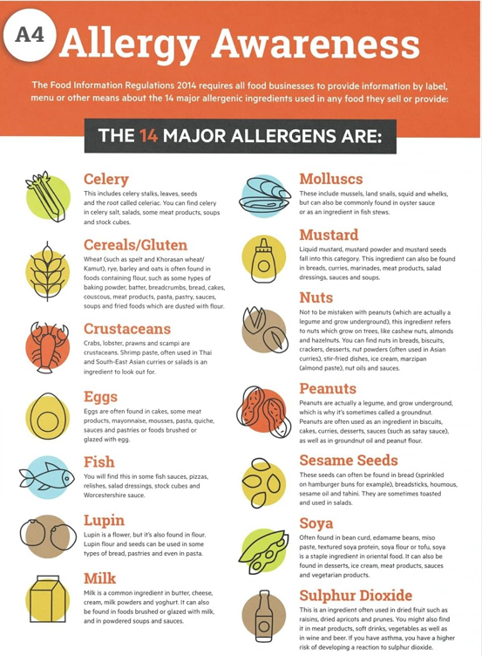

## **8.0 KEY CONTACT**

Brian Horgan

Head of Campus Food, Drink and Retail

Contact: [b.horgan@qub.ac.uk](mailto:b.horgan@qub.ac.uk)

September 2024

This policy will be reviewed annually